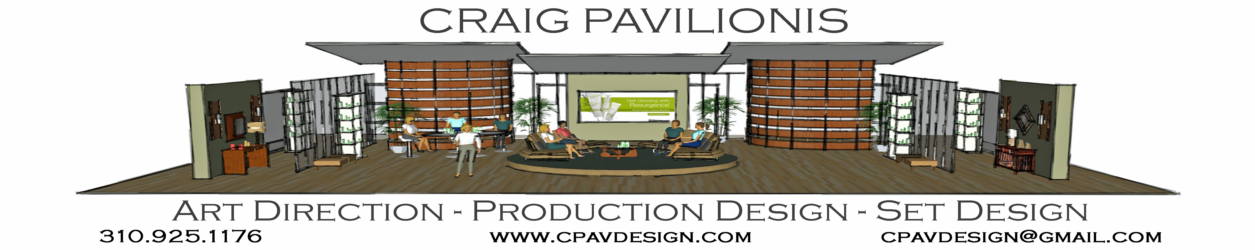

Production Designer - COMMERCIALS (partial)
Sunbelt Bakery Artistic Endeavors Dir. David Jellison
ROLEX (2019 ADG Award Nominee) Quad Productions Dir. Jan Wentz
Baby Bottle Pop Artistic Endeavors Dir. David Jellison
I am Frankie (Nickelodeon) Spots Films Dir. Peter Siaggas
Bomb Pop Artistic Endeavors Dir. David Jellison
Verizon (Nickelodeon) Artistic Endeavors Dir. David Jellison
PGA Tour (Nickelodeon) Spots Films Dir. Peter Siaggas
Brothers Grimsby Sony Pictures Movie promo Viacom Velocity / Sony Pictures Dir. Austin Reading / Chris Lenz
PEPSI MTV/Teen Wolf promo MTV Networks Dir. Chris Lenz
Comedy Central Pepsi ‘Hyped for Halftime’ Comedy Central Dir. Ryan Polito / Chris Lenz
AARP ‘Right there with you’ Accomplice Media Dir. David Jellison
Mario Brothers 2018 Kids Choice Awards Artistic Endeavors Dir. David Jellison
Bounty 2017 Kids Choice Awards Artistic Endeavors Dir. David Jellison

Production Designer - MUSIC VIDEOS (partial)
Damian Marley ‘Autumn Leaves’ 2018 DtotheS Productions Dir. Mark Pellington
Juicy J feat. The Weekend ‘One of these nights’ Pulse Productions Dir. Sam Pillen
Jennifer Hudson ‘Think Like a Man’ Robot Films Dir. Chris Robinson
Surrender the Fall ‘Love Hate Masquerade’ Rum Bum Studios Miami Dir. Michael Zoyes
Godsmack ‘Cryin Like a Bitch’ Beyond Creative Productions Dir. Paul Harb
Allison Iraheta ‘Friday I’ll be Over You’ Hello & Co Dir. James Larese
Bon Jovi ‘Who Says You Can’t Go Home’ TBJ Entertainment Dir. Anthony Bongiovi
Trey Songz ‘Last Time’ Rockhard Films Dir. Ray Kay
Art Director – MUSIC VIDEOS
PINK ‘Walk Me Home’ (Art Dir.) 2019 Partizan Dir. Michael Gracey

Art Director – COMMERCIALS (partial)
Amazon Web Services 2019 Furlined Dir. Yael Staav
Dell Technologies Partizan Dir. Antoine Bardot-Jaquet
ATT Park Pictures Dir. Terri Timely
IKEA Hungry Man Dir. Conor Byrne
Old Navy ‘HoliYays’ Rattling Stick Dir. Joel Kefali
Honda ‘Holidays’ Super Prime Dir. Augustas Punch
Safe Auto Insurance Primary Elements Dir. John Trahar
Chanel (2018 ADG Award Nominee) Rattling Stick Dir. Ringan Ledwidge
Tide Super Bowl LI Rattling Stick Dir. Sam Larson
Jose Cuervo Rattling Stick Dir. Ringan Ledwidge
iPhone 7 Furlined Dir. Henry Hobson
Toyota Great Outdoors Furlined Dir. Ted Pauly
Comcast NASCAR Biscuit Filmworks Dir. Aaron Stoller
Audi Smuggler Dir. Guard Brothers
Ford Fusion Park Pictures Dir. Chris Wilcha
Hampton Inn A White Label Dir. Oliver Gondry
Sears Anonymous Content Dir. Christian Loubek
AOL MJZ Dir. Nicolai Fuglsig
Toyota Loch Ness MJZ Dir. Rupert Sanders

LIVE MUSIC SHOWS / TOUR VIDEOS
Katy Perry ‘Roar’ on Saturday Night Live ( Art Dir ) Silent House Productions PD. Baz Halpin
Kelly Clarkson Christmas Special ( Art Dir ) Silent House Productions PD. Baz Halpin
‘PINK’ 2012 AMA’s ‘Try’ (Art Dir) Show FX PD. Baz Halpin
Jennifer Lopez Live in Baku 2012 (Décor Dir.) PEDG PD. Doug Brandt
Rhianna Live in Baku 2012(Décor Dir.) PEDG PD. Doug Brandt
Shakira Live in Baku 2012 (Décor Dir.) PEDG PD. Doug Brandt
Emmanuel ‘Unplugged’ Mexico City 2011 Rum Bum Films Miami Dir. Michael Zoyes
Green Day ’21 Guns’ 2010 Grammy’s (Art Dir.) PEDG PD. Doug Brandt
Bon Jovi ‘Lost Highway’ (roll in element video) TBJ Entertainment Dir. Anthony Bongiovi
Bon Jovi ‘Have a Nice Day’ @ Nokia Live NYC TBJ Entertainment Dir. Anthony Bongiovi
Bon Jovi ‘Bounce Tour’ roll in elements videos TBJ Entertainment Dir. Anthony Bongiovi

AWARDS / NOMINATIONS
Art Directors Guild – Excellence in Production Design
2019 Nomination as Production Designer for ROLEX
2018 Nomination as Art Director for CHANEL

Location Experience
Domestic - Los Angeles, Las Vegas, Charlotte, Albuquerque, New York City, Philadelphia, Miami
Foreign - Cabo San Lucas, Mexico City, Iceland, Istanbul Turkey, Baku Azerbaijan

