FOR IMMEDIATE RELEASE:

Art Directors Guild Represents at Comic-Con 2023 with Three Panels, Portfolio Reviews and a Booth
www.adgshowcase.com Site Features Original Artwork from Movies and TV

For Panelist Interviews or Information Requests Please Contact:
Andy Hagelshaw, Director of Communications: 747-214-3875
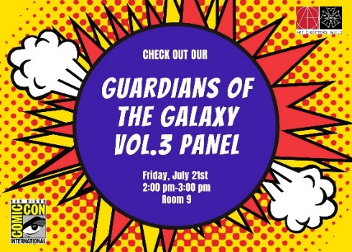

Los Angeles, July 14, 2023 - The Art Directors Guild, IATSE Local 800 (#ADG800) will have a big presence at next week’s Comic-Con with three panels at the San Diego Convention Center, a booth on the floor and special awards to be handed out at the Masquerade.

ADG 800 will kick-off the weekend with two Friday panels. The first panel features Women of the Hollywood Art Department in Room 9 on Friday, July 21 from 11:00 AM to 12:00 PM. These panelists are responsible for dreaming, designing and drawing some of the most memorable and immersive environments for film and TV. They include Amelia Brooke (Everything Everywhere All At Once, Westworld), Danelle Davenport (Shang Chi and the Legend of the Ten Rings, The Little Mermaid), Kelly Rae Hemenway (Guardians of the Galaxy Vol. 3, Bullet Train), Rupali Ingle (Star Trek: Picard, Abbott Elementary), and Daniela Medeiros (Guardians of the Galaxy Vol. 3, Thor: Ragnarok). Kate Weddle (Yellowstone, WandaVision) will moderate. Panelists will be available for autograph signing at Table# AA02 in the Sails Pavilion from 12:30 to 1:30 PM.

The artisans who created the look for the epic conclusion to the Guardians trilogy take over the same room, same day, from 2:00 PM to 3:00 PM with a panel titled Guardians of the Galaxy Vol 3 - The Art Department. From the grandeur of spaceships to a villain's geometric fortress, swimming through an endless planet of anatomy, or reconstructing a celestial body, this is the team that transported the cast, crew, and audience into these fantastic worlds. Panelists include IATSE Local 829 Production Designer Beth Mickle (The Suicide Squad, Drive), and IATSE Local 800/Art Directors Guild members: David Scott (Spider Man: No Way Home, Avengers: Infinity War), Art Director Lorin Flemming (Black Panther: Wakanda Forever, Justice League), Graphic Designer Kelly Rae Hemenway (Bullet Train, Batman vs Superman), and Set Designer Tim Croshaw (Loki, Guardians of the Galaxy Vol. 2). Moderated by Samantha Avila (Spiderman: No Way Home, Our Flag Means Death). Panelists will be available for autograph signing at Table# AA02 in the Sails Pavilion from 3:30 to 4:30 PM.

Black Panther once again descends upon Comic-Con on Saturday from 4:30 PM to 5:30 PM, in Room 29CD, with an inside look at Black Panther: Wakanda Forever- The Art Department. Find out what goes into building the vibrant Afrocentric sci-fi world of Wakanda from panelists including Oscar winning Production Designer Hannah Beachler (Black Panther, Moonlight, Creed), Concept Artist Till Nowak (The Lion King, The Lord of the Rings: The Rings of Power), Art Director Jason Clark (Mulan, Loki), Art Director Marlie Arnold (Godzilla: King of the Monsters, Loki), and Set Designer Tim Croshaw (Guardians of the Galaxy Vol. 3, Aquaman). Moderated by Storyboard Artist Jasmine Alexia Jackson (Snow White, Station Eleven). Panelists will be available for autograph signing at Table# AA02 in the Sails Pavilion from 6:00 to 7:00 PM.

ADG 800 members will be judging and presenting two awards at the Saturday evening Masquerade: The Art Directors Guild Cosplay Award for Original Concept Design, presented to the entry most exemplifying a wholly original concept, and The Art Directors Guild Cosplay Award for Best Visual Media Design, presented to the entry whose design best interprets a character or concept from a television show or motion picture. Each award comes with a $500 prize.

The ADG will be engaging the public throughout Comic-Con at booth #1500 in the main exhibition hall, as well as meeting with aspiring artists to review their portfolios on Saturday from 11:00AM to 12:00PM. The ADG Showcase website launched for Comic-Con will be available to the public showcasing the original artwork used to create the worlds of the most popular movies and TV series: www.adgshowcase.com

ABOUT THE ART DIRECTORS GUILD:
Established in 1937, the Art Directors Guild, IATSE Local 800 represents 3,300 members who work throughout the world in film, television and theater as Production Designers and Art Directors; Scenic, Title and Graphic Artists; Set Designers and Model Makers; and Illustrators and Matte Artists. ADG 800’s ongoing activities include a Film Society screening series, Annual “Excellence in Production Design Awards” gala, bimonthly craft magazine (PERSPECTIVE), figure drawing and other creative workshops, as well as extensive technology and craft training programs. For the Art Directors Guild’s online directory and resources, go to www.adg.org. Connect with the Art Directors Guild on Facebook, Twitter and Instagram.

